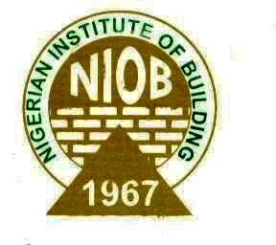
THE NIGERIAN INSTITUTE OF BUILDING
NATIONAL SECRETARIAT
COLLEGE OF FELLOWS ELECTIONS NOMINATION FORM (2020)

I………………………………………………………… a Fellow and financial member of the Institute , hereby nominate……………………………………………………. for the post of ……………………………………………………….
SUPPORTER’S SECTION
This nomination is supported by me,………………………………………..also a Fellow and financial member of the Institute.
…………………………….. …………………..…… ………………………………..… ….……………..……
SIGNATURE OF NOMINATOR/DATE GSM NUMBER SIGNATURE OF SUPPORTER/DATE GSM NUMBER

I……………………………………………., with Fellows No………………… and CORBON No:……………………………. having read the Constitution of the Institute and being aware of the duties for the Post of ……………………………………. do hereby accept to stand for election to the above post and promise to carry out my duties at all times and other assignments that may be given to me by the National Council.

………………………………. ..……………………… ……………………..
NAMES (IN BLOCK LETTERS) GSM NUMBER SIGNATURE/DATE

MANDATORY STATE CHAPTER RECOMMENDATION
I hereby confirm that the contestant is an active member of this Chapter. He is also a practicing Builder and domiciled in …………………………………. State.
Name:………………………………………….Signature:………………Date:………………GSM No:……………………(Chairman)
Name:…………………………………………..Signature:………………Date:………………GSM No:……………………(Secretary)
OFFICIAL USE ONLY
This is to certify that the candidate for the Post of ……………………………….., Bldr…………………………………and his/her nominator and supporter ,Bldrs.…………………………………………………………………………………………. are Fellows and not indebted to the Nigerian Institute of Building- National Headquarters and have fully paid their Annual Dues and Conference/Seminar/Workshop Fees.
Names of Electoral Committee Members
Name: …………………………………………………………….Signature:………………………Date:………………… (Chairman)
Name: …………………………………………………………….Signature:………………………Date:………………… (Member)
Name: …………………………………………………………….Signature:………………………Date:………………… (Member)
The Nomination form should be returned through fellows@niobnat.org and hgs@niobnat.org on or before 11:59pm on 22nd September, 2020.
N.B:
1. Attach a one page previous experience and contributions to NIOB and the Building profession.
2. Please ensure that your financial obligations to your profession are fulfilled by yourself and sponsors
3. Indicate if you have ever been convicted of any criminal offence in any Court in Nigeria.

